1 Answer
up vote 3 down vote accepted | The first is much better. On MyISAM tables it will use a full text index against those columns. The other will do a full table scan doing a concat on every row and then a comparison.  LIKE is only efficient if you're doing it against:  - a column (not a result of a function unless your particular database vendor supports functional indexes--Oracle, for example--and you're using them);  - the start of the column (ie LIKE 'blah%' as opposed to LIKE '%blah%'); and  - a column that's indexed.  If any one of those conditions are not true the only way for the SQL engine to execute the query is by doing a full table scan. This can be usable under about 10-20 thousand rows. Beyond that it quickly becomes unusable however.  Note: One problem with MATCH on MySQL is that it seems to only match against whole words so a search for 'bla' won't match a column with a value of 'blah'.

Boolean search

Hide links within definitionsShow links within definitions

Definition
Use of Boolean operators (also called logical operators) such as AND, OR, NOT, in making keyword-based text searches more precise. Boolean operators can be used with most database and web-search engines. Named after the UK mathematician George Boole (1815-64) who in 1847 introduced mathematical (symbolic) logic the foundation on which electronic computing is based.

Home > Solutions > Encyclopedia > Boolean search


Search:   Browse the index
Definition of: Boolean search
A search for data that meets several criteria by using the Boolean operators AND, OR and NOT (see Boolean logic). For example, the request: "Search for all Spanish and French speaking employees who have MBAs" would be written as follows if the query were expressed in a command line. Spanish and French are placed in parentheses in order to be treated as a single item.
list for degree = "MBA" and
(language = "Spanish" or language = "French")
In the following example, the parentheses are missing, and the query is incorrect. The AND ties MBA and Spanish together; therefore, people who speak Spanish and have an MBA would be selected, which is correct. However, the OR separates French from the rest of the query, and anyone speaking French, no matter which degree they held, would also be selected.
list for degree = "MBA" and
language = "Spanish" or language = "French"

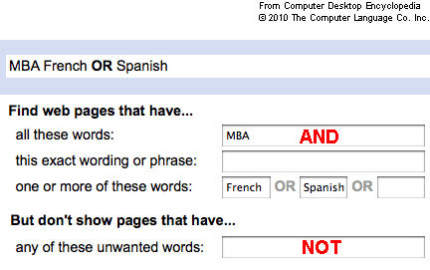
A Google "Advanced" (Boolean) Search
Searching text on Web pages is much less exact than querying records in a database, and this search actually produced 10 million results. However, the Boolean concept does still apply. In this Google "Advanced Search," the OR is stated clearly, but the AND and NOT operators are there nonetheless.
Read more: http://www.businessdictionary.com/definition/Boolean-search.html#ixzz10XIuCJv5

